# **GENERAL INFO**

* *Course: 313CCS-5*
* *Assignment no: 2*
* *Marks: 4 marks*
* *Due Date on 21-May-2023*
* *Submit on Blackboard 1 pdf file.*
* *For extra credit, the game should be uncommon, and algorithms should be well written*
* *For issues, email me immediately.*
* ***Important Note!*** 
  + *You are not allowed to use any external sources without citation, including any AI-assisted tools.*
  + *Your answer must show and reflect your effort and views.*

Find or **invent a board game notion that involves challenges and more than one player.** Then, answer the following questions.

1. **What is the name of your game (if it does not, make one)?**

**CTR**

**Crash team racing.**

1. **Sketch or draw the game idea and the board if available.**

It is a racing game between a very large number of characters in the fictional world, which is divided into two parts, the good guys and the bad guys, and each section has a number of players from which the player can choose any of the characters available to play.

The game includes several types of play, including racing for the first place in its two types online, including offline, including time challenges, including challenges of fighting with explosive cars, and many more.

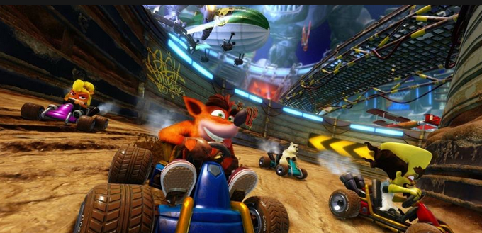Screenshot of the game:

1. **Write about how to play the game?**

In general, the game depends on the buttons associated with the device used to play, so the player in racing mode must outpace all other players and win first place.

The game has three rounds as a minimum. It does not matter who wins the first two rounds, but you must be the winner of the last round to be considered the winner of the first.

The game also provides a system for fighting cars between friends, which is about breaking boxes and brothers

1. **What are the Game Rules, including winning and losing events?**

In the main mode of the race, the player must be ahead of all other players.

The player must discover shortcuts to win the race faster.

The player must break as many boxes as possible and use their contents to fight and attack other NPCs.

To win, the player must pass all players and take at least the first place in the last round.

The loss is if one of the characters managed to win the first place, except for the player himself.

1. **Write an algorithm for loading and saving the player’s data. Start, for example, start from “when the user clicks ctrl+s ”. (Note! The data and their types must be clearly specified)**

**To save a game:**

1. Click ctrl+s to start the save
2. Window appear to enter:
3. Player name (string)
4. Level on (int)
5. Number of prizes (int)
6. Press save
7. close

**To load a game:**

1. Click ctrl+l to open the files they saved
2. Write the name of player (string)
3. Select level (int)
4. Press load
5. close
6. **Explain if there is an economic system, spawning process, or use of Randomness in the game?**

First, the economic system within the game is a bit difficult, as the player at every stage he wins gets a few coins to use in the store in unlocking new characters that are still unlocked or buying new car colors and new structures, and so on. Because of the difficulty in obtaining coins, it is a fun challenge for many. of players.

As for the spawning system, the game provides several stages for each stage, paths in which the player may fall into the void, which provides a non-player character called Burdaqa to restore the character and raise it again in the same place where it stopped.

As for randomness, the paths are full of boxes that the player breaks and randomly obtains an object that helps him speed up or slow down the play of others, or even bombarding them with a missile that delays them for some time.